**Project and Developer Details**

**Project Name:** LockedMe**.**com (Virtual Key for Your Repositories)

**Language Use:** Java

**Software Use:** eclipse

**Developer Details:**

**Developer Name: Bhushan Ladhe**

**Project Details :**

This project gives user capability to list the files present in this directory as well as add and remove files from this directory. It also gives the user a capability to search all the files with a particular name in the directory.

**Sprint Details**

**Sprint 1 Details:**

In the first sprint a basic structure to the application was developed, with the simple capability of listing the files present in the root directory.

The application has a three tier structure. Main menu, Sub menu and the data access layer.

1. Main menu is responsible for taking the inputs from the user as well as showing the output to the user. Thus it is the layer which communicates with the user.
2. Sub Menu is responsible for gives more options to user and take the input from the user.
3. The data access layer process this user input and performs the operation as per the user input.

This basic structure was created using various classesand interfaces. Also the logic to list the files present in the root directory was developed.

**Sprint 2 Details:**

The above application was enhanced to add features like :

1. Creating a new file
2. Delete the file
3. Search a file

This included creating a submenu. And adding the above options. New methods had to be created for this purpose.

* Testing the Java program with different kinds of User input.
* Pushing code to Github.

**Algorithm and Flowchart**

|  |  |  |
| --- | --- | --- |
| **Class** | **Method** | **Description** |
| FileOperation’s |  | Perform various operation like list all files in ascending order, create new file, delete file and search file using data structure concepts. |
|  | void listAllFiles() | The Method listallfiles in directory in ascending order and display the file present in directory of given path. |
|  | void createNewFile(String filename) | The method gives user to create new file in the directory and gives the output as a file created successfully else gives output as a file already exists in the given directory. |
|  | void deleteFile(String filename) | The method take user input as a String and deleting the file in directory which match with user input with files present in directory and gives the output to user. |
|  | void searchFile(String filename) | The method take user input as a String and search the file in directory which match with user input with files present in directory and gives the output to user. |
| Menu |  | This class provides various options to user to choose any options by user convenience . |
| LockedMeMain |  | Main class and also display welcome message with developer details . |

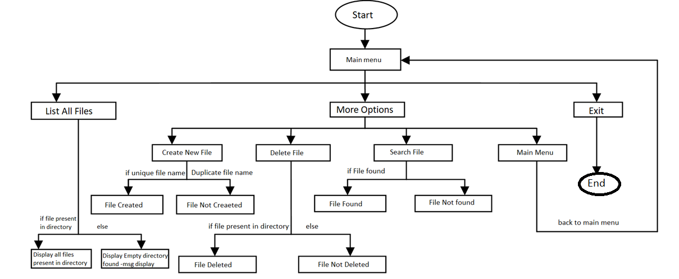

**Core concepts used in the project :-**

1. Classes
2. Constructors
3. Sort method
4. Collections
5. File class
6. For, Switch Case, If-Else ladder, and other logic related functions.

**Virtual Key for Your Repositories(LockedMe.com) Github Repository Link:-**

**https://github.com/Bhushan-077/final-project1.git**

**Unique Selling Points of the Application :-**

* The application is designed to keep on running and taking user inputs even after exceptions occur. To terminate the application, appropriate option needs to be selected
* The application can take any file name as input and save the file to the user directory.
* The user is able to seamlessly switch between options or return to previous menueven after any required operation like adding, searching, deleting or retrieving of files is performed.
* Theoption to retrieve files in ascending order is selected, sorted file will be display to the user.

**Conclusion**

There is a huge scope of improvement in the present project, one can easily add the functionality for navigating within files, and adding, deleting files within a folder of the directory. Also a functionality to write within the text files can be added. The project is that once fully developed it can act as a complete file management system and can be used by individuals to safe keep data in serialised form. That is an additional feature that needs to be implemented thereby one can keep his data in a secure format .